

**Q-Learning:**

**Effects of Algorithmic Improvements and Different Settings on Brick Breaker Game Performance**

|  |  |
| --- | --- |
| Name | Tan Zhun Xian |
| Student ID | 20313854 |
| Module | COMP3071 |
| Lecturers | * Dr Rodney Petrus Balandong * Dr Nabil El Ioini |
| Date | 10/05/2023 |

Contents

Introduction 3

Literature Review 3

Graphical User Interface (GUI) 4

Game Settings 4

Parameter Settings 5

Experiment Settings 6

Hyperparameter Settings 7

Experiment 8

Game Settings 8

Parameter Settings 8

Hyperparameter Tuning 8

Results 8

Game Settings 9

Parameter Settings 10

Hyperparameter Tuning 11

Discussion 12

Game Settings 12

Parameter Settings 13

Hyperparameter Tuning 14

Conclusion 14

Reference 14

Appendix 15

Game Settings 15

Parameter Settings 17

Hyperparameter Tuning 18

# Introduction

Reinforcement learning is a machine learning training method where desired behavior is rewarded while undesirable behavior is penalized. These are called positive and negative reinforcement respectively. A reinforcement learning agent is capable of observing and interpreting its environment, acting then receiving a reward or penalty based on its action. A reinforcement learning agent is said to learn through trial and error.

In this paper, we will be focusing on the topic of positive reinforcement by using the game Brick Breaker as the environment. In Brick Breaker, a player bounces a ball to destroy bricks by moving a paddle left and right. The player loses if the ball leaves the screen and wins if all bricks are destroyed.

Q-Learning is the reinforcement algorithm utilized in this paper. The foundation of the code was written by Matthew Chan and is available at medium.com1. The code has been modified to work with the game.

This paper aims to study the effects of different improvements of Q-Learning on the agent performance. Combinations of these improvements will then be tested to determine the best combination and get the best possible results. The effects of varying the game settings on the agent performance will also be studied and documented.

Genetic algorithm will also be employed in this paper and is used to determine the hyperparameters of the Q-Learning agent. Different techniques such as single/double crossover and tournament/roulette selection are used to ensure more variety during the evolution process to produce better results.

A GUI was also created for users to more easily change the settings of the project and streamline the process of hyperparameter tuning and data collection.

# Literature Review

The main innovation in this paper is to combine existing improvements of the Q-Learning agent to produce a new, better solution. In the end, 7 research papers of interest were identified and listed below.

Firstly, **genetic algorithm** was used by Wicaksono, A. S., & Supianto, A. A. for hyperparameter optimization of the machine learning methods used in online news popularity prediction2.

Secondly, H.R. Tizhoosh has introduced **opposition-based learning** as a new scheme for machine intelligence3.

Thirdly, the **granularity of the state space** was shown to affect the results by Jacopo Fior and Luca Cagliero in their study of machine learning-based stock trading4.

Furthermore, Michal Gregor and Juraj Spalek have also done research on optimistic exploration value functions5. This has been adapted in this project as the **random initialization of the Q-tables**.

Moreover, research into action elimination with deep reinforcement learning6 has also been done by Tom Zahavy, et al. This has been adapted to varying the **size of the action space** in the project.

Apart from that, research into **different reward functions** on the training performance of a Double DQN7 has also been done by Stefan Šćepanović.

Finally, Double Q-Learning was introduced by Hado van Hasselt which lacks the overestimation bias of the Q-Learning algorithm8. This has adapted to **N-tuple Q-Learning** which is another innovation in this paper where N Q-tables were created for each reinforcement learning agent.

Thus, we can study the effects of combining multiple improvements and ascertain the best combination with the best results.

# Graphical User Interface (GUI)

As mentioned above, users can easily change the settings of the project using the GUI created. Users can run experiments or perform hyperparameter tuning by pressing one of the two buttons below.

## Game Settings

The game settings allow users to customize the different aspects of the game.

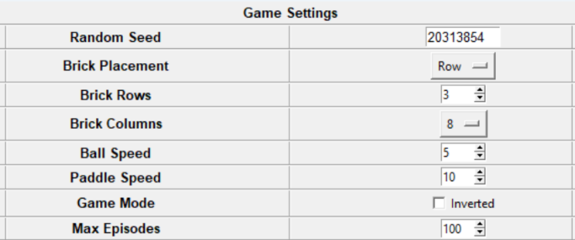

***Figure 1: Game Settings***

* **Random Seed**

|  |  |
| --- | --- |
| Range | 0 – 4294967295 |
| Default | 20313854 |
| Description | Integer used to initialize the pseudorandom number generator to ensure that results are reproducible. |

* **Brick Placement**

|  |  |
| --- | --- |
| Options | Row, Column, Random |
| Default | Row |
| Description | Controls how the 3 brick types are arranged in game.  **Row:** by row  **Column:** by column  **Random:** random |

* **Brick Rows**

|  |  |
| --- | --- |
| Range | 1 – 10 |
| Default | 3 |
| Description | The number of brick rows in the game. |

* **Brick Columns**

|  |  |
| --- | --- |
| Options | 1,2,3,4,5,6,8,10,12,15 |
| Default | 8 |
| Description | The number of bricks in each row. Can only be a factor of 600 up to 15. |

* **Ball Speed**

|  |  |
| --- | --- |
| Range | 1 – 10 |
| Default | 5 |
| Description | The speed of the ball in the game. |

* **Paddle Speed**

|  |  |
| --- | --- |
| Range | 5 – 15 |
| Default | 10 |
| Description | The speed of the paddle in the game. |

* **Game Mode**

|  |  |
| --- | --- |
| Options | False, True |
| Default | False |
| Description | Allows inversion of the position of the bricks and paddle in the game. |

* **Max Episodes**

|  |  |
| --- | --- |
| Range | 1 – 200 |
| Default | 100 |
| Description | The number of failed episodes before the game is reset and recorded as a failed run. |

## Parameter Settings

The parameter settings allow users to control the different settings of the Q-Learning agent.

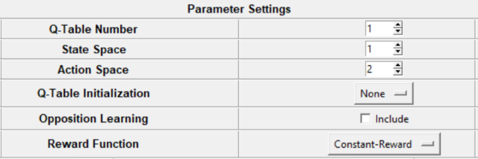

***Figure 2: Parameter Settings***

* **Q-Table Number**

|  |  |
| --- | --- |
| Range | 1 – 5 |
| Default | 1 |
| Description | The number of Q-tables generated for each agent. |

* **State Space**

|  |  |
| --- | --- |
| Range | 1 – 8 |
| Default | 1 |
| Description | The granularity of the state space. State is assigned based on distance between the ball and the paddle. |

* **Action Space**

|  |  |
| --- | --- |
| Options | 2, 3 |
| Default | 2 |
| Description | The size of the action space. The 2 default actions are for the paddle to move left and right. The 3rd action is to do nothing. |

* **Q-Table Initialization**

|  |  |
| --- | --- |
| Options | None, Normal, Uniform |
| Default | None |
| Description | The initial values of the Q-tables.  **None:** 0s  **Normal:** -10 – 10  (Normal distribution)  **Uniform:** -10 – 10  (Uniform distribution) |

* **Opposition Learning**

|  |  |
| --- | --- |
| Options | False, True |
| Default | False |
| Description | Allows the agent to also take the opposite action. The do-nothing action has no opposite action and is only called once. |

* **Reward Function**

|  |  |
| --- | --- |
| Options | Constant-Reward,  Turn-Count,  X-Distance,  X-Distance-Paddle,  XY-Distance |
| Default | Constant-Reward |
| Description | The reward function used by the agent.  **Constant-Reward:**  1 if run not ended else 0  **Turn-Count:** turn count  **X-Distance:** 6 – distance (ball.mid.x, paddle.mid.x)  **X-Distance-Paddle:**  6 – minimum distance (ball.mid.x, paddle.x)  **XY-Distance:** 7.5 – dist (ball.mid, paddle.mid) |

## Experiment Settings

The experiment settings allow users to change the hyperparameters and compare the experiment results. It is accessed by pressing the experiment button.

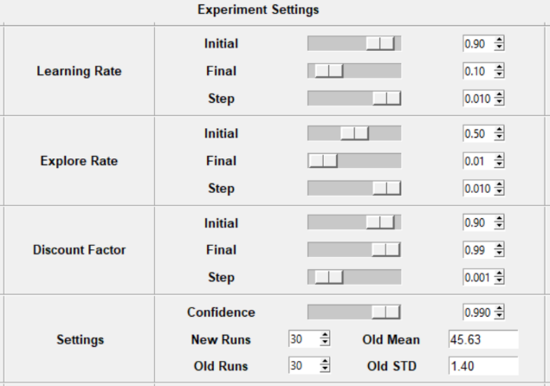

***Figure 3: Experiment Settings***

* **Learning Rate**

|  |  |
| --- | --- |
| Range | 0.00 – 1.00 / 0.000 – 0.010 |
| Default | 0.90 / 0.10 / 0.010 |
| Description | How much the new learned value is used. |

* **Explore Rate**

|  |  |
| --- | --- |
| Range | 0.00 – 1.00 / 0.000 – 0.010 |
| Default | 0.50 / 0.01 / 0.010 |
| Description | The chance that a random action is taken instead of the best action. |

* **Discount Factor**

|  |  |
| --- | --- |
| Range | 0.00 – 1.00 / 0.000 – 0.010 |
| Default | 0.90 / 0.99 / 0.001 |
| Description | The importance of future rewards. |

* **Confidence**

|  |  |
| --- | --- |
| Range | 0.500 – 0.999 |
| Default | 0.990 |
| Description | The confidence level of the t-test used to evaluate the results of the different experiments. |

* **New Runs**

|  |  |
| --- | --- |
| Range | 30 – 100 |
| Default | 30 |
| Description | The number of successful runs needed for results collection. |

* **Old Runs**

|  |  |
| --- | --- |
| Range | 30 – 100 |
| Default | 30 |
| Description | The size of the old sample to be compared. |

* **Old Mean**

|  |  |
| --- | --- |
| Range | 1.00 – 200.00 |
| Default | 45.63 |
| Description | The mean of the old sample to be compared. |

* **Old STD**

|  |  |
| --- | --- |
| Range | 0.00 – 140.71 |
| Default | 1.40 |
| Description | The standard deviation of the old sample to be compared. |

## Hyperparameter Settings

The hyperparameter settings allow users to control the process of hyperparameter tuning of the agent. It is accessed by pressing the tuning button.

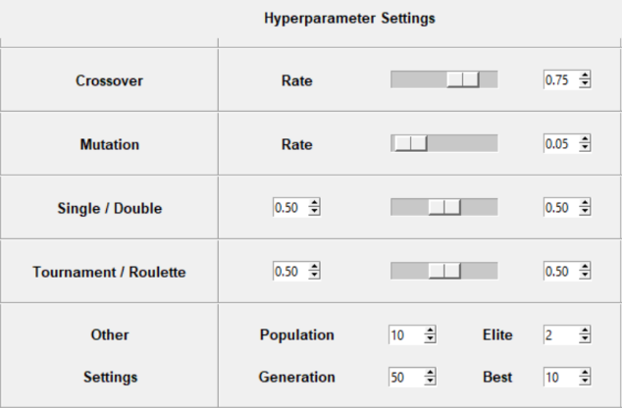

***Figure 4: Hyperparameter Settings***

* **Crossover Rate**

|  |  |
| --- | --- |
| Range | 0.00 – 1.00 |
| Default | 0.75 |
| Description | The percentage of chromosomes that undergo crossover. |

* **Mutation Rate**

|  |  |
| --- | --- |
| Range | 0.00 – 1.00 |
| Default | 0.05 |
| Description | The percentage of genes that undergo mutation. |

* **Single / Double**

|  |  |
| --- | --- |
| Range | 0.00 – 1.00 |
| Default | 0.50 / 0.50 |
| Description | The percentage of single and double crossover when crossover occurs. |

* **Tournament / Roulette**

|  |  |
| --- | --- |
| Range | 0.00 – 1.00 |
| Default | 0.50 / 0.50 |
| Description | The percentage of tournament and roulette selection for the selection of the next generation. |

* **Population**

|  |  |
| --- | --- |
| Range | 10 – 100 (±2) |
| Default | 10 |
| Description | The population size of each generation. |

* **Elite**

|  |  |
| --- | --- |
| Range | 0 – 10 (±2) |
| Default | 2 |
| Description | The number of fittest chromosomes guaranteed to survive each generation. |

* **Generation**

|  |  |
| --- | --- |
| Range | 1 – 100 |
| Default | 50 |
| Description | The number of iterations of genetic algorithm. |

* **Best**

|  |  |
| --- | --- |
| Range | 1 – 10 |
| Default | 10 |
| Description | The number of fittest chromosomes displayed at the end. |

# Experiment

The experiments to be run are listed below. The results of the default settings are used as the baseline for comparison. The experiments are run at least 30 times for the Central Limit Theorem to hold and to ensure statistical significance of the results. All t-tests have 99% confidence level.

## Game Settings

Firstly, each **game** setting is varied individually and the results recorded. The **mean** of the results is studied to determine the effects of each game setting on the game.

## Parameter Settings

Secondly, each **parameter** setting is varied individually and the results recorded. The expected **difference** in mean of the results is studied to determine the effects of each parameter setting on the Q-Learning agent.

Different parameter settings are then combined to determine which parameter combination produces the best results.

## Hyperparameter Tuning

Genetic algorithm is run for 50 generations with the default settings and the best parameter combination found above. The fittest 10 chromosomes are recorded below.

The fitness value of each chromosome is determined by running the experiment only once for the sake of time. To reduce the overestimation bias, if the same chromosome is evaluated more than once, the worst result is taken as the fitness value.

Finally, experiments are then run with the fittest chromosomes and the best parameter combination found above. The results are used to determine the best hyperparameter settings which produces the best results.

# Results

Metrics such as the mean, STD and difference are recorded with the full list in the appendix. The most important metric is the **difference**, d which shows the expected difference in mean between the 2 samples.

Categorical variables are analyzed using bar charts while numerical variables use line graphs in their analysis.

For game settings, we study the **mean** while we study the **difference** for parameter settings. For hyperparameter tuning, we use the hyperparameters found to run experiments then study the **difference**.

$$t=\frac{\left(m_{2}-m_{1}\right)-d}{s_{p}\sqrt{\frac{1}{n_{1}}+\frac{1}{n_{2}}}}$$

***Figure 4: t-test Formula***

$$d=\left(m_{2}-m_{1}\right)-t_{0.01}×s_{p}\sqrt{\frac{1}{n_{1}}+\frac{1}{n_{2}}}$$

***Figure 5: Difference Formula***

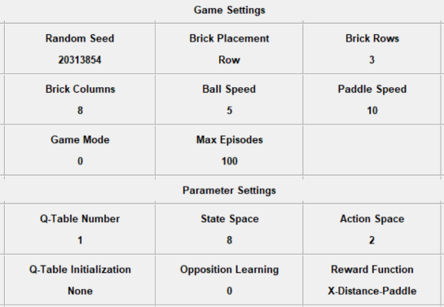

***Figure 6: Final Settings Screen***

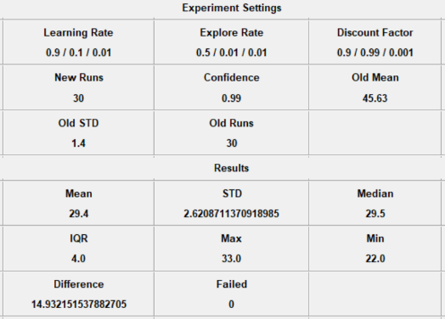

***Figure 7: Experiment Results Screen***

## Game Settings

The results of varying the game settings are shown below. We only study the **mean** as the difference is not relevant here. A **lower** mean signifies a better result.

* **Brick Placement**

There are only minor differences in the results of different brick placements.

* **Brick Rows**

As the number of brick row increases, the mean of the results also increases.

* **Brick Columns**

As the number of brick columns increases, the mean of the results also increases.

* **Ball Speed**

As the ball speed increases, the mean of the results decreases before increasing again.

* **Paddle Speed**

After an initial high, the mean of the results remains relatively stable.

* **Game Mode**

Both game modes have identical results.

## Parameter Settings

The results of varying the parameter settings are shown below. We study the expected **difference** in mean to discover which parameters have the greatest improvements on the results. A **higher** difference means a better result.

* **Q-Table Number**

As the number of Q-tables increases, the difference also increases along with the number of failed runs.

* **State Space**

As the number of state space increases, the difference also increases.

* **Action Space**

When the action space increases, there is minimal difference between the results.

* **Q-Table Initialization**

There is no difference between initializing the Q-tables with 0s or random values.

* **Opposition Learning**

**Constant-Reward** fails but **X-Distance-Paddle** shows good results.

* **Reward Function**

Only one of the reward function, **X-Distance-Paddle** shows a significant difference while the rest have none.

|  |  |
| --- | --- |
| **Symbol** | **Reward Function** |
| CR | Constant-Reward |
| XP | X-Distance-Paddle |
| TC | Turn-Count |
| X | X-Distance |
| XY | XY-Distance |

* **Parameter Combination**

**Random** was excluded from combination as there was no difference in the results. All other parameters were included.

|  |  |
| --- | --- |
| **Symbol** | **Parameter Settings** |
| R | Reward - X-Distance-Paddle |
| S | State - 8 |
| O | Opposition - True |
| A | Action - 3 |
| Q | Q-Table - 5 |

We choose **R** as the first parameter. By combining **R** with the other 4, we find that **RS, RO** > **R** > **RA,** **RQ**. Thus, we then combine **RS** + **RO** into **RSO**. However, we find that **RS** > **RSO** > **RO**. So, we conclude that **RS** is the best parameter combination.

## Hyperparameter Tuning

The **RS** parameter combination is used in genetic algorithm. The settings used and the final fittest chromosomes are listed below arranged in the order Initial / Final / Step and are given in percentages (%).

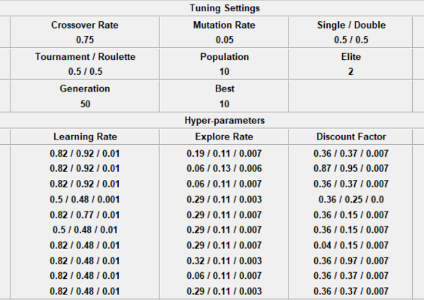

***Figure 8: Hyperparameter Results Screen***

* **Final Chromosomes**

These are the final 10 fittest chromosomes.

|  |  |  |  |
| --- | --- | --- | --- |
| No | Learning | Explore | Discount |
| 1 | 82/92/1.0 | 19/11/0.7 | 36/37/0.7 |
| 2 | 82/92/1.0 | 06/13/0.6 | 87/95/0.7 |
| 3 | 82/92/1.0 | 06/11/0.7 | 36/37/0.7 |
| 4 | 50/48/0.1 | 29/11/0.3 | 36/25/0.0 |
| 5 | 82/77/1.0 | 29/11/0.7 | 36/15/0.7 |
| 6 | 50/48/1.0 | 29/11/0.7 | 36/15/0.7 |
| 7 | 82/48/1.0 | 29/11/0.7 | 04/15/0.7 |
| 8 | 82/48/1.0 | 32/11/0.3 | 36/97/0.7 |
| 9 | 82/48/1.0 | 06/11/0.7 | 36/37/0.7 |
| 10 | 82/48/1.0 | 29/11/0.3 | 36/37/0.7 |

* **Chromosome Results Sorted**

These are the results of combining the chromosomes with **RS** sorted by **difference** in descending order. Most results have a **difference** greater than 40 with the **best** difference of 43.12 and a **mean** of only 1.83.

* **Final Chromosomes Sorted**

These are the final chromosomes sorted based on the sorted chromosome results.

|  |  |  |  |
| --- | --- | --- | --- |
| No | Learning | Explore | Discount |
| 1 | 82/92/1.0 | 19/11/0.7 | 36/37/0.7 |
| 3 | 82/92/1.0 | 06/11/0.7 | 36/37/0.7 |
| 9 | 82/48/1.0 | 06/11/0.7 | 36/37/0.7 |
| 2 | 82/92/1.0 | 06/13/0.6 | 87/95/0.7 |
| 10 | 82/48/1.0 | 29/11/0.3 | 36/37/0.7 |
| 5 | 82/77/1.0 | 29/11/0.7 | 36/15/0.7 |
| 7 | 82/48/1.0 | 29/11/0.7 | 04/15/0.7 |
| 4 | 50/48/0.1 | 29/11/0.3 | 36/25/0.0 |
| 6 | 50/48/1.0 | 29/11/0.7 | 36/15/0.7 |
| 8 | 82/48/1.0 | 32/11/0.3 | 36/97/0.7 |

# Discussion

The results of the experiments will now be discussed so that we may gain better insight into the different settings of the experiments.

## Game Settings

First, we discuss the effects of varying the game settings on the results.

* **Brick Placement**

As seen above, there is minimal difference in the results of different brick placements. This is because the overall objective of the game is still the same which is to break 3 rows of bricks without losing the ball. The difference in results comes from the positioning of the 3 different types of bricks.

* **Brick Rows**

As the number of row increases, the mean of the results also increases. When the number of row increases, the number of bricks also increases. This increases the length of the game and gives the agent more chances to commit mistakes and lose the game. So, the number of episodes increases.

However, the rate of increase of the episodes slows down as the number of rows increases. As the length of the game increases, the agent becomes a better player and makes less mistakes thus fewer extra episodes are needed to beat the game.

* **Brick Columns**

As the number of columns increases, the mean of the results also increases. The reasoning is similar to the one above where increasing the number of bricks increases the length of the game and gives the agent more chances to lose. The rate of increases also slows down as the agent slowly becomes a better player at the game.

* **Ball Speed**

As the ball speed increases, the mean of the results decreases before increasing again along with the number of failed runs.

A reinforcement learning agent needs to win and lose to learn the correct moves. When the ball is slow, it takes more turns to move and lose. The agent takes longer to learn the correct moves and the number of episodes needed is higher. So, increasing the ball speed decreases the episode mean.

After a certain point, the ball moves and loses so quickly that the agent has no time to learn. This causes the failure rate to increase as the ball speed increases.

* **Paddle Speed**

After an initial high along with a high number of failed runs, the mean of the results remains relatively stable.

For the paddle, its movement speed is not very important. It just has to be fast enough to catch the ball. So, increasing the paddle speed does not affect the mean very much.

However, issues arise when the paddle is too slow. The paddle may not be able to traverse the screen to catch the ball and this causes failure rates to increase. Thus, any paddle speed above 5 is usable.

* **Game Mode**

Both game modes have identical results. Inverting the bricks and paddle position has no effect on the results. This is due to the fact that the agent is training against the same 3 rows of bricks and thus the only difference is to invert the controls.

## Parameter Settings

Next, we discuss the effects of varying the parameter settings on the results.

* **Q-Table Number**

As the number of Q-tables increases, the difference also increases along with the number of failed runs.

As mentioned above, Double Q-Learning was able to reduce the overestimation bias in the best Q-value. By increasing the number of Q-tables, the overestimation bias is reduced further and leads to better results.

However, the increase in Q-tables also increases the number of state spaces that the agent must fill. If correctly filled, we can expect better results. If not, the agent will fail to choose the correct moves. As the number of state space increases, the chances that they are not filled correctly and thus the failure rate increases.

* **State Space**

As the number of state space increases, the difference also increases. The granularity of the state space is also important in getting the best results. If the state space is too coarse, it may not be effectively separated. If it is too fine, we end up with redundant state spaces. For the agent, it is clear that the state space is too coarse and thus we get better results as we increase the state space.

* **Action Space**

When the action space increases, there is minimal difference between the results. Choosing the correct action space is also important in getting good results. In this case, the 3rd action of do nothing is meaningless and does not contribute to the results. The reason a small improvement still exists may be because the **Constant-Reward** reward function used is even more uninformative. However, more meaningful actions may actually lead to better results.

* **Q-Table Initialization**

There is no difference between initializing the Q-tables with 0s or random values. The simplicity and short length of the game may be to blame. Exploration is promoted in the early stages with random values. A longer and complex game may see better results.

* **Opposition Learning**

Opposition learning works by also taking the opposite action so there is twice the information available. **Constant-Reward** gives identical results for both actions so nothing is learned. **X-Distance-Paddle** gives different results so it learns twice as fast and thus has better results.

* **Reward Function**

For reward functions, the most important thing is the amount of information received. The more informative the reward, the better.

**Constant-Reward** and **Turn-Count** both learn a longer run is better but **Turn-Count** is dominated by its later moves. **X-Distance** performs worse than **X-Distance-Paddle** because the distance from the whole paddle is more important than just the midpoint. **XY-Distance** performs the worst as the vertical distance is irrelevant to the agent.

* **Parameter Combination**

The **Reward** function is chosen because it is more informative. **State** works well as we separated the state space effectively. **Opposition** works well as the agent gets twice the information. **Action** works poorly as the do-nothing action is meaningless. **Q-Table** works poorly as the reward is already informative but we have more spaces to fill. Combining **State** and **Opposition** works poorly as the different parameters may interfere with each other. There is also a limit to how much the results can be improved naturally which can only be breached by changing the hyperparameters.

## Hyperparameter Tuning

Finally, we discuss the results of hyperparameter tuning below. The top 5 hyperparameters are given.

|  |  |  |  |
| --- | --- | --- | --- |
| No | Learning | Explore | Discount |
| 1 | 82/92/1.0 | 19/11/0.7 | 36/37/0.7 |
| 3 | 82/92/1.0 | 06/11/0.7 | 36/37/0.7 |
| 9 | 82/48/1.0 | 06/11/0.7 | 36/37/0.7 |
| 2 | 82/92/1.0 | 06/13/0.6 | 87/95/0.7 |
| 10 | 82/48/1.0 | 29/11/0.3 | 36/37/0.7 |

Firstly, a high learning rate is preferred so the new learned value is fairly important.

Secondly, a moderately low explore rate is best. The explore rate needs to be low enough so the agent can still take the best action most of the time while high enough to encourage sufficient exploration.

Finally, the discount factor needs to be moderate. The agent should place more emphasis on immediate rewards but also put a little focus into future rewards.

# Conclusion

In conclusion, Q-Learning has been successfully used to teach an agent to play the game Brick Breaker. The experiments were successfully run using the GUI given.

The effects of varying the game and parameter settings were studied. The best combination of parameters is the correct **Reward** function and a high **State** space.

**Genetic algorithm** was then used to tune the hyperparameters. It was discovered that the best hyperparameters were a high learning rate, a moderately low explore rate and a moderate discount factor.

The best results obtained by the agent is an episode **mean** of only 1.83 and a **difference** of 43.12 with a 99% confidence level.

A good extension to the project would be to adapt Q-Learning to other games.

# Reference

The list of references used are listed below.

1. <https://medium.com/@tuzzer/cart-pole-balancing-with-q-learning-b54c6068d947>
2. Wicaksono, A. S., & Supianto, A. A. (2018). Hyper parameter optimization using genetic algorithm on machine learning methods for online news popularity prediction. *International Journal of Advanced Computer Science and Applications*, *9*(12).
3. Tizhoosh, Hamid. (2005). Opposition-Based Learning: A New Scheme for Machine Intelligence. IEEE. 1. 695 - 701. 10.1109/CIMCA.2005.1631345.
4. J. Fior and L. Cagliero, "Exploring the Use of Data at Multiple Granularity Levels in Machine Learning-Based Stock Trading," 2020 International Conference on Data Mining Workshops (ICDMW), 2020, pp. 333-340, doi: 10.1109/ICDMW51313.2020.00053.
5. M. Gregor and J. Spalek, "The optimistic exploration value function," 2015 IEEE 19th International Conference on Intelligent Engineering Systems (INES), 2015, pp. 119-123, doi: 10.1109/INES.2015.7329650.
6. Zahavy, T., Haroush, M., Merlis, N., Mankowitz, D. J., & Mannor, S. (2018). Learn what not to learn: Action elimination with deep reinforcement learning. Advances in neural information processing systems, 31.
7. S. Šćepanović, "Testing reward function choice influence on training performance of Double DQN," 2022 11th Mediterranean Conference on Embedded Computing (MECO), 2022, pp. 1-4, doi: 10.1109/MECO55406.2022.9797177.
8. Hasselt, H. (2010). Double Q-learning. Advances in neural information processing systems, 23.

# Appendix

## Game Settings

* **Brick Placement**

|  |  |  |  |  |  |  |  |  |
| --- | --- | --- | --- | --- | --- | --- | --- | --- |
| Placement | Mean | S.T.D | Median | I.Q.R | Max | Min | Failed | Difference |
| Row | 45.63 | 1.40 | 46.0 | 1.0 | 47 | 40 | 0 | 0.00 |
| Column | 45.77 | 0.86 | 46.0 | 1.0 | 47 | 44 | 1 | 0.00 |
| Random | 46.33 | 0.80 | 46.0 | 1.0 | 48 | 45 | 0 | 0.00 |

* **Brick Rows**

|  |  |  |  |  |  |  |  |  |
| --- | --- | --- | --- | --- | --- | --- | --- | --- |
| Rows | Mean | S.T.D | Median | I.Q.R | Max | Min | Failed | Difference |
| 1 | 41.40 | 1.30 | 42.0 | 1.0 | 44 | 38 | 0 | 3.39 |
| 2 | 44.97 | 1.27 | 45.0 | 2.0 | 47 | 42 | 0 | 0.00 |
| 3 | 45.63 | 1.40 | 46.0 | 1.0 | 47 | 40 | 0 | 0.00 |
| 4 | 46.77 | 0.77 | 47.0 | 1.0 | 48 | 44 | 0 | 0.00 |
| 5 | 47.43 | 0.77 | 47.0 | 1.0 | 49 | 46 | 1 | 0.00 |
| 6 | 47.70 | 0.47 | 48.0 | 1.0 | 48 | 47 | 1 | 0.00 |

* **Brick Columns**

|  |  |  |  |  |  |  |  |  |
| --- | --- | --- | --- | --- | --- | --- | --- | --- |
| Columns | Mean | S.T.D | Median | I.Q.R | Max | Min | Failed | Difference |
| 1 | 33.53 | 4.60 | 34.5 | 5.0 | 39 | 18 | 0 | 10.00 |
| 2 | 37.27 | 1.51 | 37.5 | 2.0 | 40 | 33 | 0 | 7.46 |
| 3 | 38.73 | 1.51 | 39.0 | 2.0 | 41 | 35 | 0 | 6.00 |
| 4 | 42.40 | 1.73 | 43.0 | 3.0 | 45 | 39 | 0 | 2.26 |
| 5 | 43.57 | 1.76 | 44.0 | 1.0 | 45 | 37 | 0 | 1.08 |
| 6 | 44.47 | 1.22 | 44.5 | 1.0 | 46 | 42 | 1 | 0.35 |
| 8 | 45.63 | 1.40 | 46.0 | 1.0 | 47 | 40 | 0 | 0.00 |
| 10 | 46.60 | 0.67 | 47.0 | 1.0 | 48 | 45 | 0 | 0.00 |
| 12 | 47.13 | 0.73 | 47.0 | 1.0 | 48 | 46 | 1 | 0.00 |
| 15 | 47.70 | 0.65 | 48.0 | 1.0 | 49 | 46 | 1 | 0.00 |

* **Ball Speed**

|  |  |  |  |  |  |  |  |  |
| --- | --- | --- | --- | --- | --- | --- | --- | --- |
| Speed | Mean | S.T.D | Median | I.Q.R | Max | Min | Failed | Difference |
| 1 | 49.83 | 1.02 | 50.0 | 1.0 | 53 | 49 | 0 | 0.00 |
| 2 | 48.80 | 0.41 | 49.0 | 0.0 | 49 | 48 | 0 | 0.00 |
| 3 | 47.87 | 0.51 | 48.0 | 0.0 | 49 | 47 | 0 | 0.00 |
| 4 | 46.67 | 0.71 | 47.0 | 1.0 | 48 | 45 | 0 | 0.00 |
| 5 | 45.63 | 1.40 | 46.0 | 1.0 | 47 | 40 | 0 | 0.00 |
| 6 | 45.43 | 0.94 | 46.0 | 1.0 | 48 | 43 | 0 | 0.00 |
| 7 | 44.63 | 1.63 | 45.0 | 2.0 | 47 | 41 | 0 | 0.06 |
| 8 | 44.57 | 1.38 | 44.0 | 1.0 | 47 | 42 | 5 | 0.20 |
| 9 | 46.53 | 1.28 | 47.0 | 1.0 | 50 | 44 | 21 | 0.00 |
| 10 | 48.27 | 1.28 | 49.0 | 2.0 | 52 | 45 | 89 | 0.00 |

* **Paddle Speed**

|  |  |  |  |  |  |  |  |  |
| --- | --- | --- | --- | --- | --- | --- | --- | --- |
| Speed | Mean | S.T.D | Median | I.Q.R | Max | Min | Failed | Difference |
| 5 | 47.37 | 1.27 | 47.0 | 2.0 | 51 | 45 | 22 | 0.00 |
| 6 | 45.67 | 0.96 | 46.0 | 1.0 | 47 | 44 | 0 | 0.00 |
| 7 | 45.87 | 1.14 | 46.0 | 1.0 | 47 | 43 | 0 | 0.00 |
| 8 | 45.30 | 1.66 | 46.0 | 1.0 | 47 | 40 | 0 | 0.00 |
| 9 | 45.70 | 1.24 | 46.0 | 1.0 | 48 | 43 | 0 | 0.00 |
| 10 | 45.63 | 1.40 | 46.0 | 1.0 | 47 | 40 | 0 | 0.00 |
| 11 | 45.83 | 1.15 | 46.0 | 1.0 | 49 | 43 | 0 | 0.00 |
| 12 | 45.70 | 0.99 | 46.0 | 1.0 | 47 | 44 | 0 | 0.00 |
| 13 | 45.93 | 1.36 | 46.0 | 2.0 | 47 | 42 | 0 | 0.00 |
| 14 | 46.27 | 1.08 | 46.0 | 1.0 | 49 | 44 | 0 | 0.00 |
| 15 | 45.90 | 0.84 | 46.0 | 1.0 | 47 | 44 | 1 | 0.00 |

* **Game Mode**

|  |  |  |  |  |  |  |  |  |
| --- | --- | --- | --- | --- | --- | --- | --- | --- |
| Inverted | Mean | S.T.D | Median | I.Q.R | Max | Min | Failed | Difference |
| False | 45.63 | 1.40 | 46.0 | 1.0 | 47 | 40 | 0 | 0.00 |
| True | 45.63 | 1.40 | 46.0 | 1.0 | 47 | 40 | 0 | 0.00 |

## Parameter Settings

* **Q-Table Number**

|  |  |  |  |  |  |  |  |  |
| --- | --- | --- | --- | --- | --- | --- | --- | --- |
| Table | Mean | S.T.D | Median | I.Q.R | Max | Min | Failed | Difference |
| 1 | 45.63 | 1.40 | 46.0 | 1.0 | 47 | 40 | 0 | 0.00 |
| 2 | 42.47 | 4.46 | 42.0 | 7.0 | 50 | 35 | 3 | 1.12 |
| 3 | 40.30 | 3.90 | 40.0 | 4.0 | 51 | 34 | 5 | 3.52 |
| 4 | 38.93 | 2.29 | 39.0 | 4.0 | 44 | 34 | 7 | 5.52 |
| 5 | 37.13 | 2.27 | 37.5 | 3.0 | 41 | 31 | 49 | 7.33 |

* **State Space**

|  |  |  |  |  |  |  |  |  |
| --- | --- | --- | --- | --- | --- | --- | --- | --- |
| State | Mean | S.T.D | Median | I.Q.R | Max | Min | Failed | Difference |
| 1 | 45.63 | 1.40 | 46.0 | 1.0 | 47 | 40 | 0 | 0.00 |
| 2 | 43.07 | 3.26 | 44.0 | 5.0 | 47 | 36 | 0 | 1.01 |
| 3 | 40.17 | 3.61 | 40.0 | 6.0 | 46 | 34 | 2 | 3.77 |
| 4 | 38.13 | 3.09 | 38.5 | 4.0 | 43 | 29 | 0 | 6.01 |
| 5 | 37.60 | 2.88 | 38.0 | 4.0 | 42 | 30 | 0 | 6.63 |
| 6 | 35.10 | 3.99 | 35.0 | 5.0 | 45 | 27 | 0 | 8.68 |
| 7 | 33.53 | 3.12 | 33.0 | 3.0 | 41 | 28 | 0 | 10.60 |
| 8 | 30.83 | 4.19 | 30.5 | 5.0 | 42 | 22 | 0 | 12.87 |

* **Action Space**

|  |  |  |  |  |  |  |  |  |
| --- | --- | --- | --- | --- | --- | --- | --- | --- |
| Action | Mean | S.T.D | Median | I.Q.R | Max | Min | Failed | Difference |
| 2 | 45.63 | 1.40 | 46.0 | 1.0 | 47 | 40 | 0 | 0.00 |
| 3 | 44.23 | 1.30 | 44.0 | 2.0 | 47 | 42 | 0 | 0.56 |

* **Q-Table Initialization**

|  |  |  |  |  |  |  |  |  |
| --- | --- | --- | --- | --- | --- | --- | --- | --- |
| Random | Mean | S.T.D | Median | I.Q.R | Max | Min | Failed | Difference |
| None | 45.63 | 1.40 | 46.0 | 1.0 | 47 | 40 | 0 | 0.00 |
| Normal | 45.57 | 1.57 | 46.0 | 0.0 | 47 | 40 | 0 | 0.00 |
| Uniform | 45.23 | 1.61 | 46.0 | 1.0 | 48 | 39 | 0 | 0.00 |

* **Opposition Learning**

|  |  |  |  |  |  |  |  |  |
| --- | --- | --- | --- | --- | --- | --- | --- | --- |
| Opposition | Mean | S.T.D | Median | I.Q.R | Max | Min | Failed | Difference |
| False | 36.87 | 3.01 | 37.0 | 4.0 | 44 | 32 | 0 | 7.31 |
| True | 31.43 | 3.79 | 32.0 | 4.0 | 40 | 24 | 0 | 12.43 |

* **Symbol Mapping**

|  |  |  |  |
| --- | --- | --- | --- |
| **Symbol** | **Reward Function** | **Symbol** | **Parameter Settings** |
| CR | Constant-Reward | R | Reward - X-Distance-Paddle |
| XP | X-Distance-Paddle | S | State - 8 |
| TC | Turn-Count | O | Opposition - True |
| X | X-Distance | A | Action - 3 |
| XY | XY-Distance | Q | Q-Table - 5 |

* **Reward Function**

|  |  |  |  |  |  |  |  |  |
| --- | --- | --- | --- | --- | --- | --- | --- | --- |
| Reward | Mean | S.T.D | Median | I.Q.R | Max | Min | Failed | Difference |
| CR | 45.63 | 1.40 | 46.0 | 1.0 | 47 | 40 | 0 | 0.00 |
| XP | 36.87 | 3.01 | 37.0 | 4.0 | 44 | 32 | 0 | 7.31 |
| TC | 46.50 | 4.13 | 46.0 | 5.0 | 59 | 42 | 0 | 0.00 |
| X | 48.23 | 1.77 | 48.0 | 2.0 | 54 | 45 | 0 | 0.00 |
| XY | 76.87 | 4.20 | 77.5 | 4.0 | 85 | 65 | 3 | 0.00 |

* **Parameter Combination**

|  |  |  |  |  |  |  |  |  |
| --- | --- | --- | --- | --- | --- | --- | --- | --- |
| Combination | Mean | S.T.D | Median | I.Q.R | Max | Min | Failed | Difference |
| One | | | | | | | | |
| R | 36.87 | 3.01 | 37.0 | 4.0 | 44 | 32 | 0 | 7.31 |
| Two | | | | | | | | |
| RS | 29.40 | 2.62 | 29.5 | 4.0 | 33 | 22 | 0 | 14.93 |
| RO | 31.43 | 3.79 | 32.0 | 4.0 | 40 | 24 | 0 | 12.43 |
| RA | 39.97 | 3.47 | 39.0 | 4.0 | 49 | 35 | 0 | 4.03 |
| RQ | 40.10 | 3.53 | 40.0 | 4.0 | 50 | 35 | 0 | 3.87 |
| Three | | | | | | | | |
| RSO | 29.63 | 4.94 | 30.0 | 8.0 | 40 | 21 | 0 | 13.75 |

## Hyperparameter Tuning

* **Chromosome Results Sorted**

|  |  |  |  |  |  |  |  |  |
| --- | --- | --- | --- | --- | --- | --- | --- | --- |
| Chromosome | Mean | S.T.D | Median | I.Q.R | Max | Min | Failed | Difference |
| 1 | 1.83 | 0.65 | 2.0 | 1.0 | 3 | 1 | 0 | 43.12 |
| 3 | 2.30 | 0.95 | 2.0 | 1.0 | 4 | 1 | 0 | 42.59 |
| 9 | 2.37 | 1.22 | 2.0 | 2.0 | 5 | 1 | 0 | 42.45 |
| 2 | 2.63 | 1.67 | 2.0 | 3.0 | 8 | 1 | 0 | 42.04 |
| 10 | 3.47 | 2.27 | 3.0 | 3.0 | 9 | 1 | 0 | 41.00 |
| 5 | 3.90 | 1.77 | 4.0 | 2.0 | 8 | 1 | 0 | 40.74 |
| 7 | 3.73 | 2.55 | 3.0 | 3.0 | 10 | 1 | 0 | 40.63 |
| 4 | 4.30 | 2.41 | 4.0 | 4.0 | 10 | 1 | 0 | 40.11 |
| 6 | 4.77 | 2.24 | 4.0 | 3.0 | 11 | 2 | 0 | 39.71 |
| 8 | 7.60 | 4.67 | 7.5 | 6.0 | 18 | 1 | 0 | 35.90 |